# VSTS 2010 Training

Project Management

Requirement Management

Version Control

Test Case Management

Build Automation

Reporting

Lab Management (Test environment simulation)

Process Template.

How about:

Code profiling, Code metrics.

It seems VS2010 emphasize more on test.

## SCRUM

Microsoft is pushing SCRUM. The VS2010 is deved under SCRUM.

51Testing, TestAge.

小的迭代周期叫做Sprint (2-4 weeks), 每个Sprint定义一个优先级需求列表，Srpint Backlog (user story).

Daily Scrum Meeting (Stand up meeting: 15 minutes).

User story need have corresponding TC.

### Meetings:

Sprint Planing Meeting

Daily Scrum Metting

Sprint Review Meeting

Sprint Retrospective Meeting

### Documents:

Product Backlog

Sprint Backlog

Burndown Chart

TFS2010 的MSF支持SCRUM Agile.

SCRUM is suitable for a team that has worked together for 2 years or more.

## Architecture

Sequence Diagram

Class Diagram

Use Case Diagram

Activity Diagram

UML Component Diagram

Layer Diagram: Architecture/code validation.

Directed Graph Document

Under Menu->Architecture. or View->Architecture Explorer

## High Quality Code Management

Debug History: IntelliTrace - Historical Debugger. Can record history and dump as files.http://msdn.microsoft.com/en-us/library/dd264954%28VS.100%29.aspx

Debug Calibration using iTrace debug file. Is this available in release mode?

Breakpoint Import/Export

DataTips Import/Export

## Database Development

Support extending for other DBs in addition to SQLServer, using Extension Manager.

## Unit Test and TDD

Quick Search

Class generation from the test code to support TDD.

Better support to Data Driven Test through DataSource custom attribute on the test method.

## Source Control

Better branchpass

## Team Build

Build Server Pool

Continues Integration

Gated Checkin

Workflow based build

## Test

Test and Lab manager

Improved Manual Tests and Coded UI Test.

Manual Test: Video-Recorder, Action Log, Bug File, IntelliTrace.....Easy to re-produce bug.

Coded UI Test: Record and Modify. As automated UI test.

Test Impact Analysis for code modification

Test management: test suite.

## Code Focused Development

Code focused deveopment: Consume first, declare later; generate from usage -- easy for test code

Code insight: show call hierarchy.

Improve ASP.NET development. Ajax, HTML&Sliverlight, Dynamic data tooling.

Improved Office development

Sharepoint development

Debugger: 64-bit mixed mode, minidump debugging, WPF visualizer.

Smarter search

Code Snippet Editor

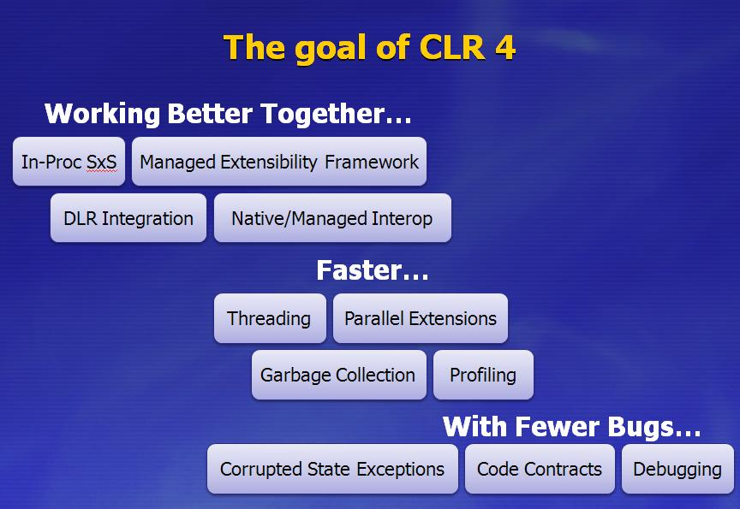

With DLR, we can call Python in C# or vice versa.

## BCL Improvements

BigIntgeger, Complex,

Tuple, SortedSet<T>, ISet<T>

Memory-Mapped File

Unified Cancellation Model.

Contract Information(VS2010 extension)

.NET 4.0 Generic changes: in, out.

## WCF

Tightly integrated with WF.

Message Routing Service and Protocal Briding.

Flexibilty & Backward compatibility & Security & Request Dispatching vs Limited performance hurt.

Exception will be passed back through the Routing Service.

Service Discovery

## WF

New product with the same name. (Even MS does this, too)

No StateMachine, replaced by FlowChart. Sequence is kept. State Machine may be added later.

Focus on what not how.

The granularity is Activity.

WAS

The workflow is edited in either pure XAML mode or pure Code mode. If we wanna our own code, we need implement our own activity by deriving CodeActivity. Then the activity can be used in the whole workflow.

## Entity Framework

Model-First: Previously only DB->Model is supported. Model -> DB is supported.

Complex types.

## Server Enhancement

When entity framework as WCF:

Row count support and page by page fetch

Server-Side paging.

BLOP Streams

WPF Data Binding with Data Service Context

## ASP.NET

Support for SEO (Search Engine Optimization): RouteURL

Cleaner HTML

Productivity and Extensibility

Rich Ajax: EnableCdn

JQuery is part of the web project.

Ajax Toolset.

Enable dynamic data for GridView, DetailsView, FormView, ListView

New Chart Control.

Better caching, pre-load, pre-cache on app start.

Check how to store data using javascript. I think we need put it into some html element，如隐藏的表单元素

Didin't see the upload control improvement...

## WPF

Full Trust Xbap

MultiTouch, Ribbon,Common Dialogs.....

We can only get Ribbon after register Office license on the web site...

WPF client framework deployment package.

Can we interact between .NET 3.5 and .NET 4.0. Google backword compatibility of .NET 4.0.

## Parallel Programming

Play with COB.

Unified Cancellation Model